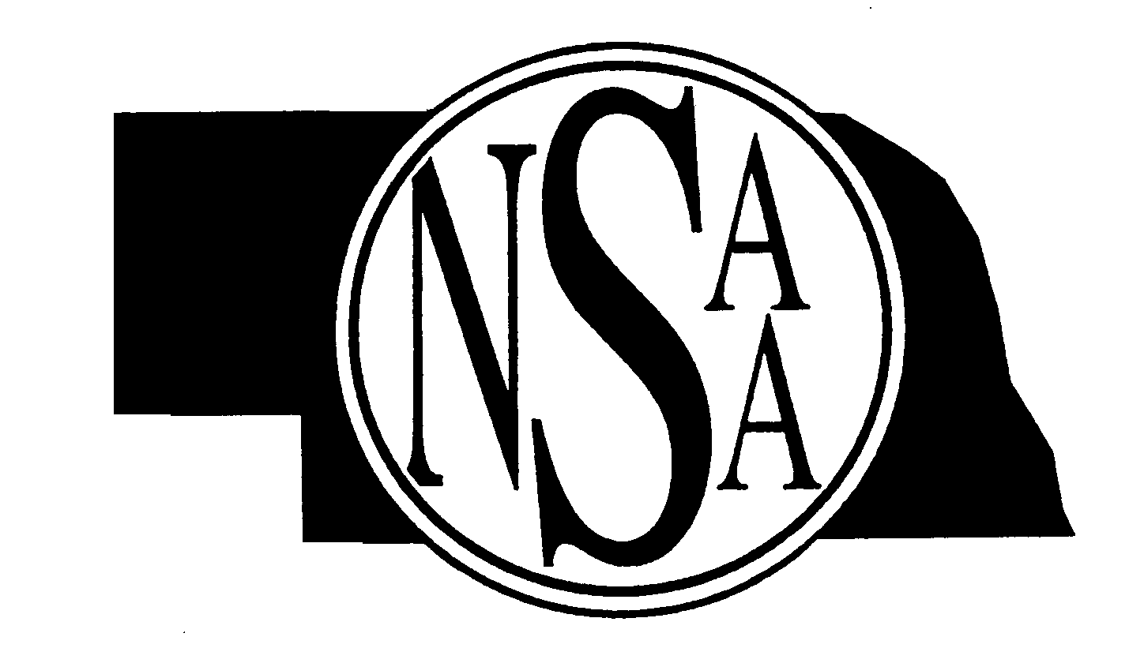

2009-2010 Speech/Play Production
RULES MEETINGS

Before gaining access to a rules meeting, you must pay the registration fee. The NSAA is offering FREE on-line rules meetings for a limited time period, which will satisfy the rules meeting requirement for head coaches and judges. During the two week “no charge” period, head coaches and judges can access the online rules meeting using their NSAA passcode.

NEW JUDGES: Go to the NSAA Home Page – Click on the Speech or Play Production link. Refer to the first item in regard to judge’s registration.

Last Year’s NSAA Registered Judges: Go to the NSAA Home Page - Login with your NSAA judge’s passcode. For those individuals that are a Head Speech or Play Production coach AND a Judge - please login with your judges passcode only to view the rules meeting.

October 5 to October 18 No Charge to Judges & Head Coaches
October 19 to October 25 Basic $25 Fee – Judges and Head Coaches
October 26 to October 29 Late/Penalty $50 Fee – Judges and Head Coaches

RULES MEETING SCHEDULE
*All meetings will start at 7:00 p.m., unless otherwise noted.

Tuesday, September 8 North Platte High School
Wednesday, September 9 Chadron High School
Wednesday, September 9 ESU 13 Sidney
Western Nebraska Community College, --
Scottsbluff - Harms Technology Center Room 188
Monday, September 14 Omaha Westside High School, Room 220
Tuesday, September 15 Grand Island High School, West Commons
Monday, September 21 Norfolk High School
Tuesday, September 23 NSAA Office, Lincoln
Thursday, October 1 Kearney Ramada Inn

For Speech and Play Production inquiries please e-mail Debra Velder at: dvelder@nsaahome.org
Judges’ Registration Inquiries please e-mail Cindy Callaway at ccallaway@nsaahome.org

